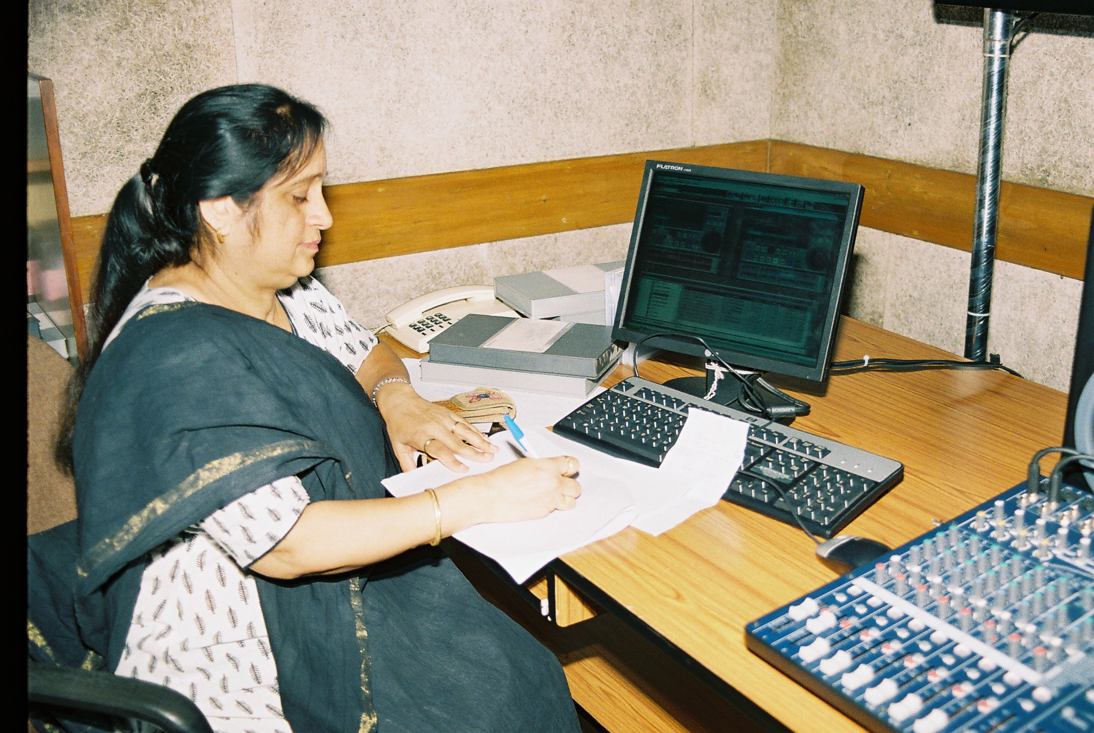
Ms. Anita Malhotra
TV Producer Grade III
LIST OF VEDIO PROGRAMMES PRODUCED
2009–2010
 | Media Matters- Part II | Media | Teachers | 25 min
 | Media Matters- Part III | Media | Teachers | 12 min 30 sec
 | Bahadur Rajkumar Part I | Folk Tale | Primary | 9 min 30 sec
 | Bahadur Rajkumar Part II | Folk Tale | Primary | 11 min 30 sec
 | Kala Aur Saundryabodh ki Kaksha | Art and Aesthetics | Secondary | 14 min 20 sec
 | Ghumantu Ki Duniya Part II | Art | Primary | 11 min 46 sec
 | Shanti Ki Aur | Art | Secondary | 9 min 8 sec
 | Sabse Bada Dharm Ahinsa | Art | Secondary | 8 min 20 sec
 | Kathak Bharatnatyam Aur Lok Nritya Ka Samagam | Art | Secondary | 2 mins,30 sec
 | Kathak Nritya | Art | Secondary | 5 min 20 sec
 | Gunvatta Puran Shiksha (Panel Discussion) | General | Teachers | 18 min
 | Classroom teachers with puppet | Art | Primary | 11 min
 | Ghumantu Ki Duniya Part I | Art | Primary | 10 min 9 sec
 | Sankhyaon ka Laghutam Smapvartya | Maths | Primary | 16 min
 | Bharatnatyam | Art | Secondary | 4 min 32 sec
 | Practices and policies of national curriculum in South Asian countries | General | Teachers | 60 min
 | Introduction to language of dance | Art | Upper Primary | 20 min
 | Coordination of body and mind  Creative movements | Art | Upper Primary | 25 min 14 sec
 | Introduction to classical dances of India | Art | Upper Primary | 22 min
 | Historical references and  five jaathi | Art | Upper Primary | 18 min
 | Paadbhedas [feet movements and positions] | Art | Upper Primary | 17 min
 | Basics of dance Adavu 1 | Art | Upper Primary | 23 min
 | Basics of dance Adavu 2 | Art | Upper Primary | 18 min
 | Basics of dance Adavu 3 | Art | Upper Primary | 16 min
 | Language of gestures  Single and double hand | Art | Upper Primary | 15 min
 | Usages of gestures—  Patakaah | Art | Upper Primary | 16 min
 | Usages of gestures—  Ardh Patakaah | Art | Upper Primary | 18 min
 | Usages of tripatakaah  Karthari mukah | Art | Upper Primary | 14 min
 | Shirobhedas  Movements of the head gesture | Art | Upper Primary | 16 min 58 sec
 | Drishti and greeva  Movements of eyes and neck | Art | Upper Primary | 23 min

